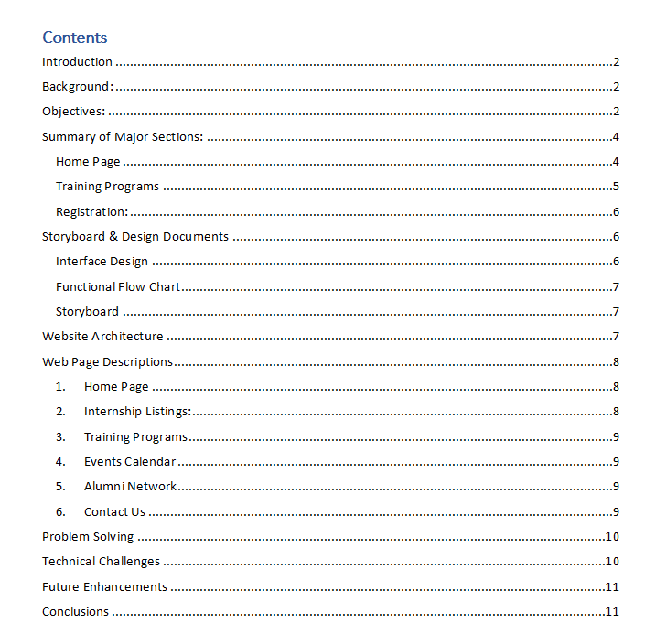

Acknowledgement

We extend our heartfelt gratitude to all individuals who have contributed to the successful completion of the Training and Placement Cell Website project. Our sincere appreciation goes to our faculty members, project advisors, colleagues, and college administration for their guidance, support, and encouragement throughout the project's development.

# Introduction

The Training and Placement Cell Website project is aimed at creating an interactive digital platform to bridge the gap between academia and industry. This section provides an overview of the project, outlining its background, objectives, scope, target audiences, project schedule, and a summary of the major sections of the website.

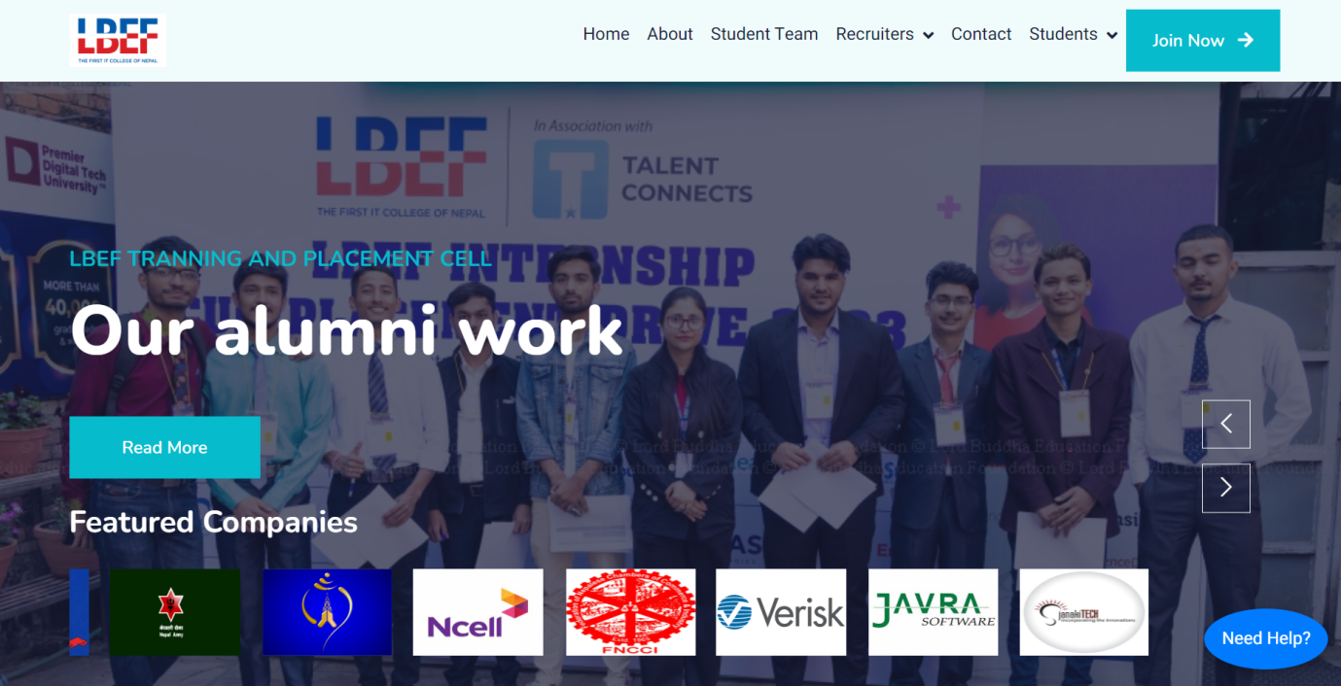

Background: The Training and Placement Cell (TPC) at Lord Buddha Education Foundation (LBEF) was established to empower students with career opportunities, training, and internships. The website serves as a centralized hub for students and stakeholders to access information, register for programs, and enhance their professional skills.

# Objectives:

* Develop an engaging website to showcase TPC's offerings and services.
* Facilitate effective communication between students, alumni, faculty, and corporate partners.
* Provide students with information about internships, training programs, and career-related events.
* Enhance user experience through intuitive design and user-friendly navigation.

**Scope:** The project involves designing and implementing a responsive website for TPC that includes sections for internships, training programs, events, alumni connections, and contact information. The scope does not extend to the integration of an online application system for internships.

**Target Audiences:** The website caters to current and prospective students, faculty, alumni, corporate partners, and community members interested in career development and opportunities.

**Project Schedule:**

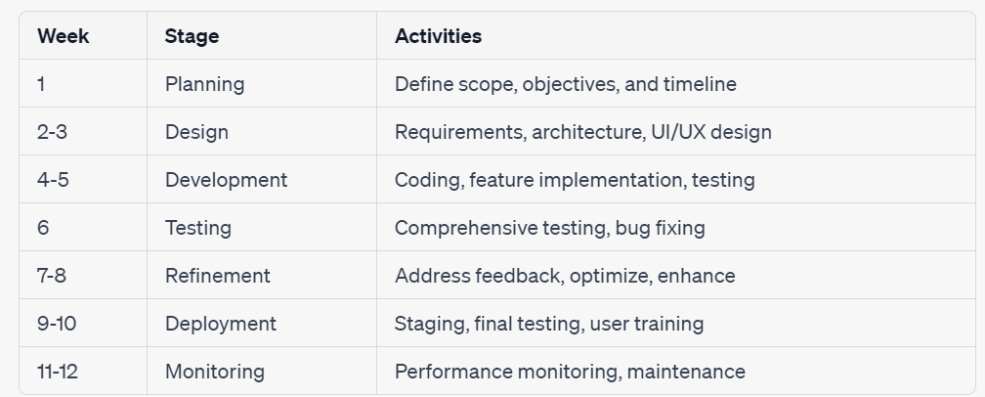

Summary of Major Sections: The website's major sections include the

## Home Page



Internship Listings,

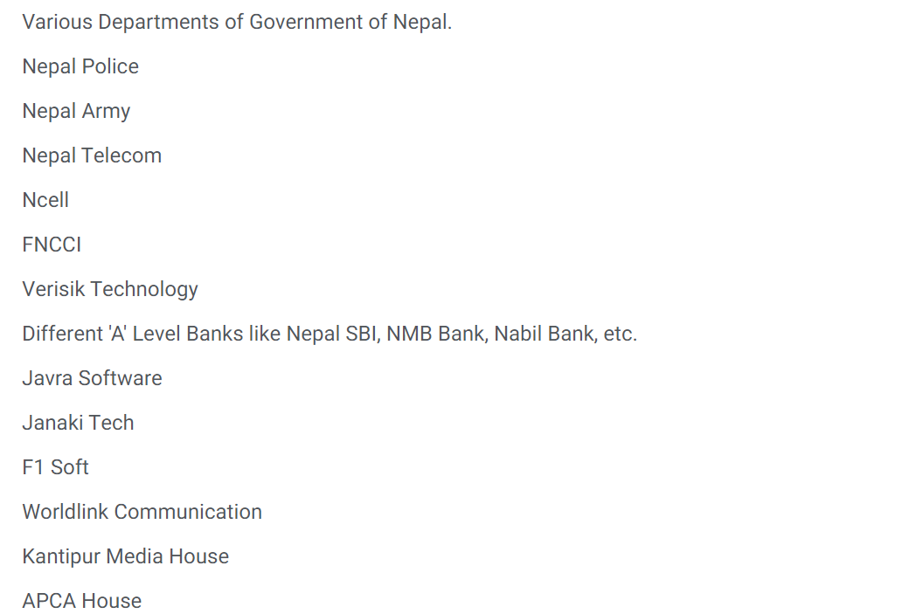

## Training Programs

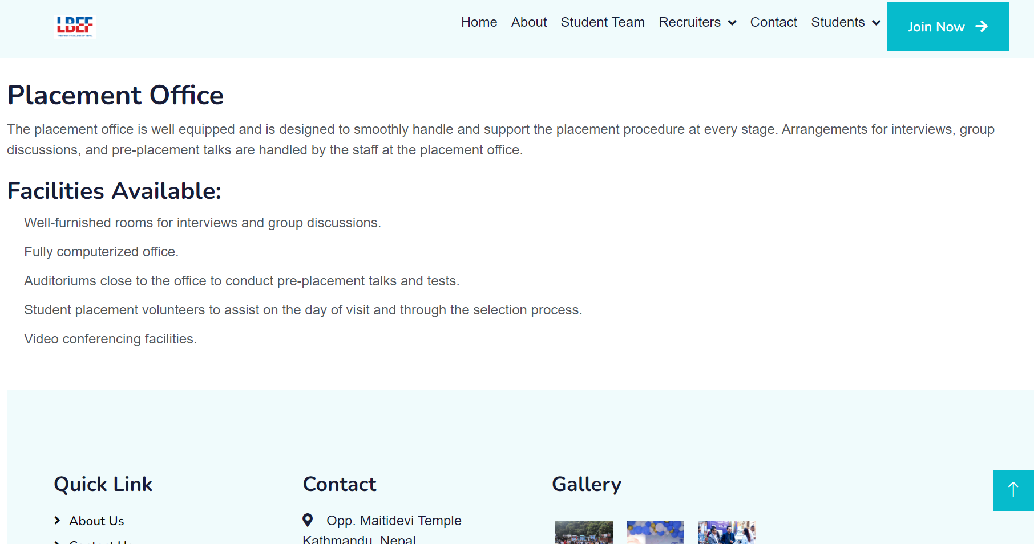

## Registration:

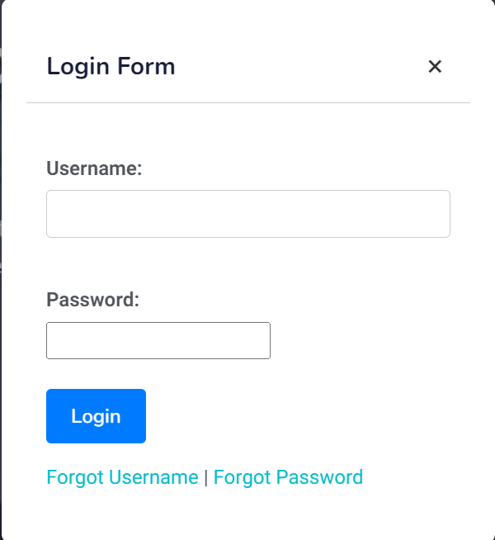

# Storyboard & Design Documents

## Interface Design

The website's design will feature a modern and professional look, employing a color palette consistent with the college's branding. The typography will utilize a clean and readable sans-serif font. This design approach aims to evoke a sense of trust and professionalism.

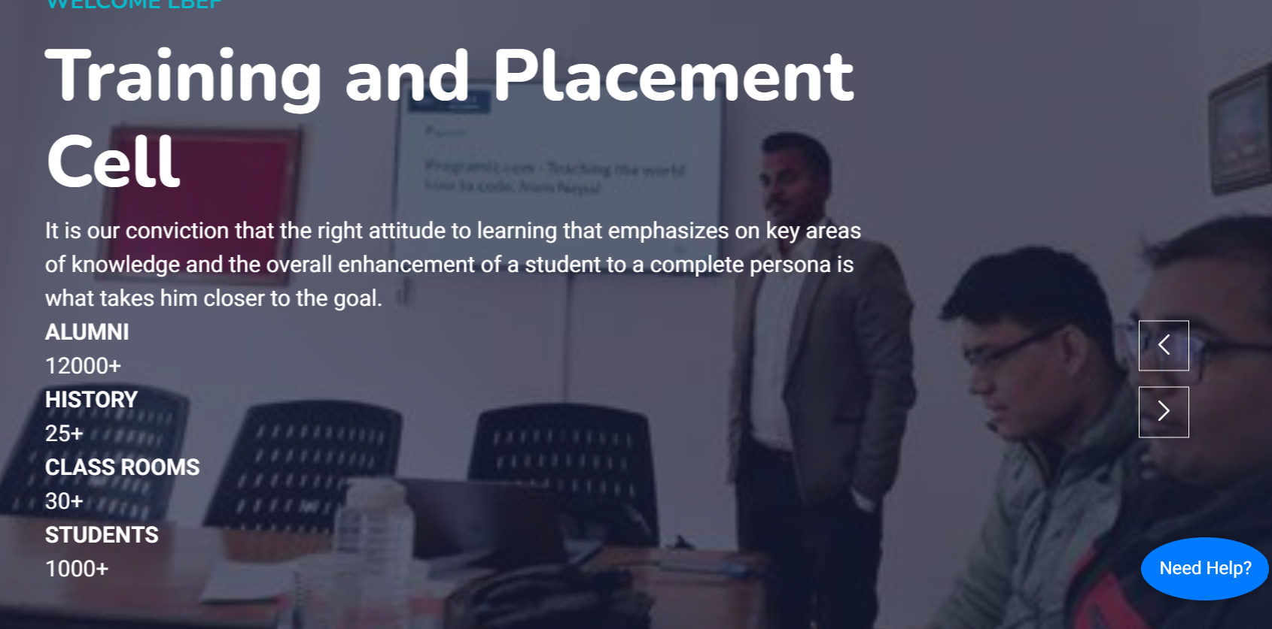

## Functional Flow Chart

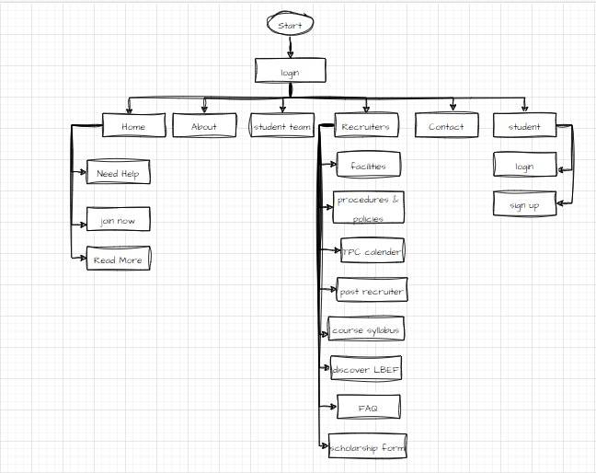

## Storyboard

The storyboard consists of wireframes and mockups that depict the visual layout of key pages, including the homepage, internship listing page, training program details, events calendar, and alumni network. These visual representations provide a clear overview of the website's structure and content arrangement.



# Website Architecture

The website architecture comprises a front-end interface accessible to users and a back-end system for administrators to manage content. A database stores information about internships, training programs, and registered users. This architecture ensures efficient data organization and retrieval.

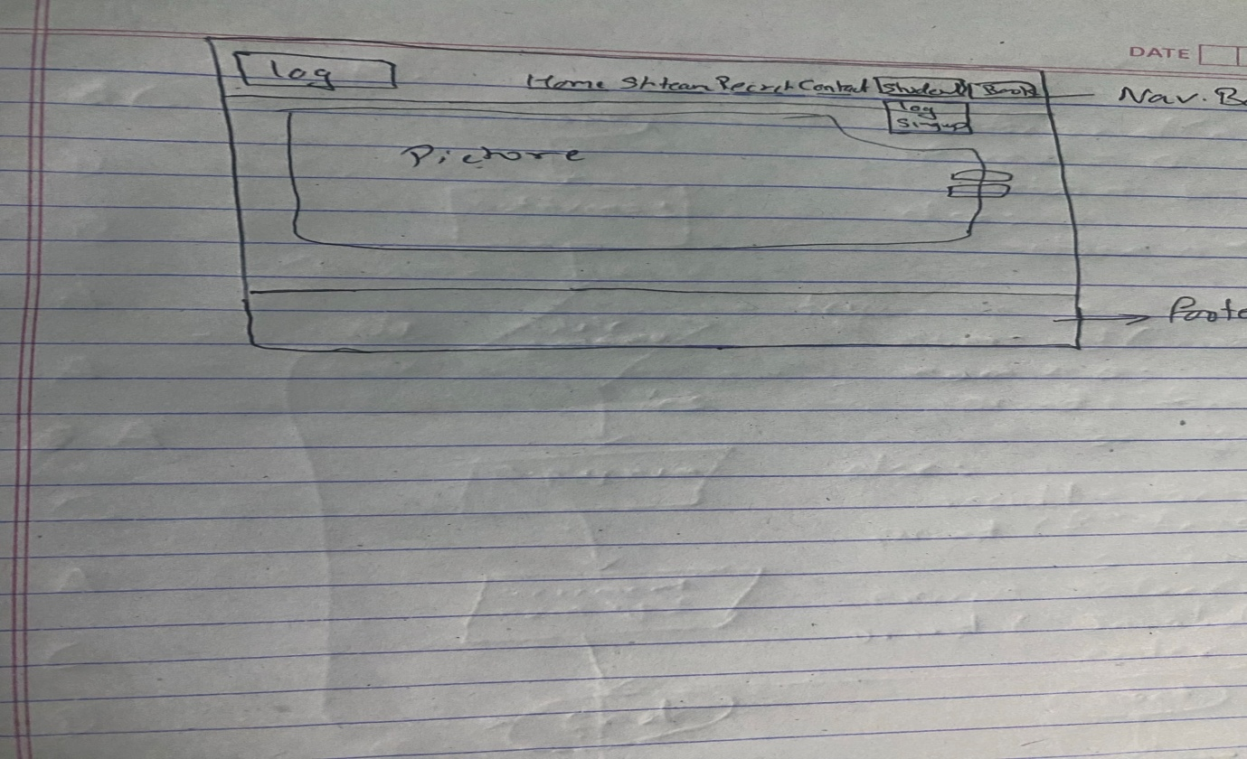

# Web Page Descriptions

1. Home Page**:** The welcoming homepage introduces TPC's services, with quick links to major sections.



1. Internship Listings: Details available internships, providing information on application deadlines and requirements.



1. Training Programs**:** Describes various skill-enhancement programs and sessions.
2. Events Calendar**:** Displays upcoming seminars, workshops, and career events.

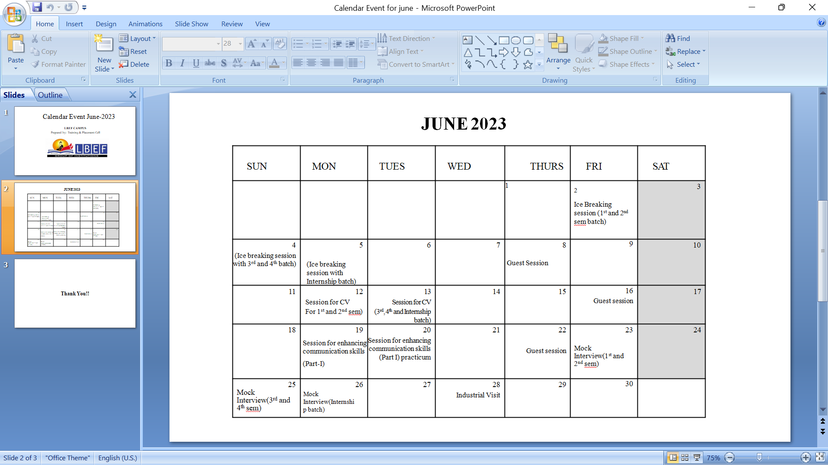

1. Alumni Network**:** Showcases successful alumni stories and their career trajectories.

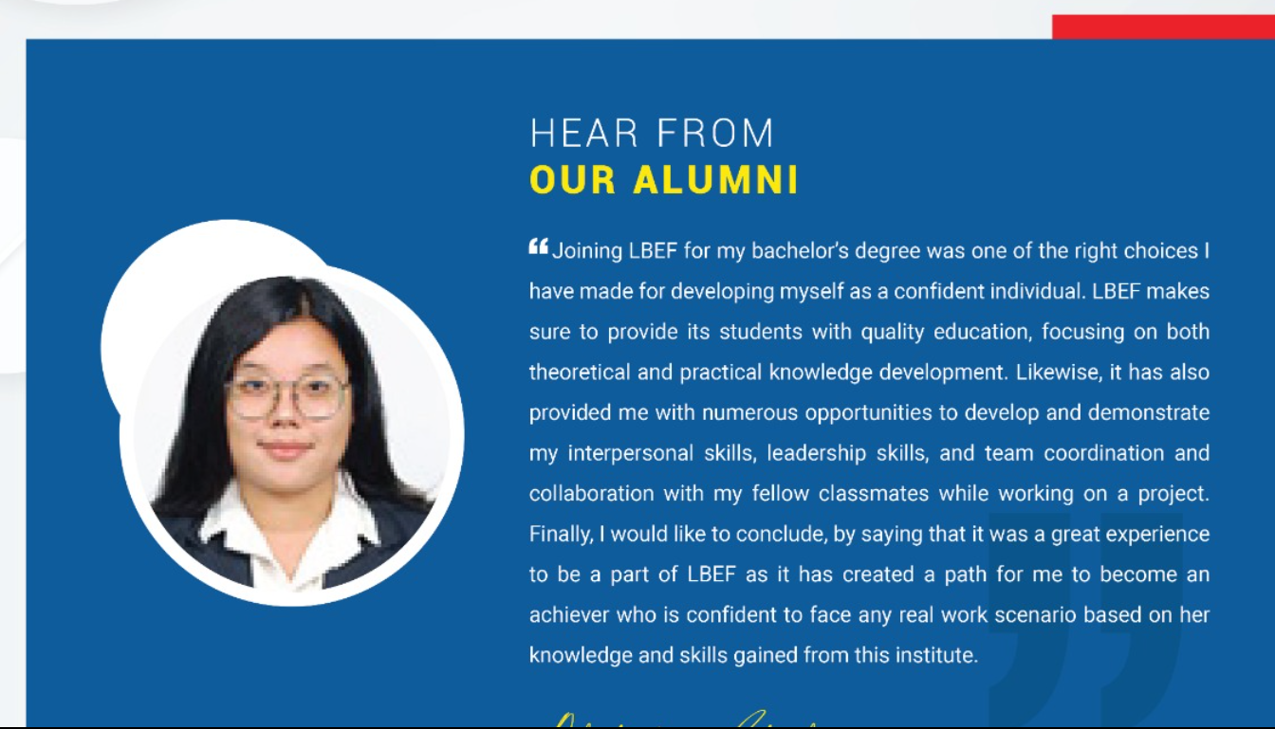

1. Contact Us**:** Offers contact details.

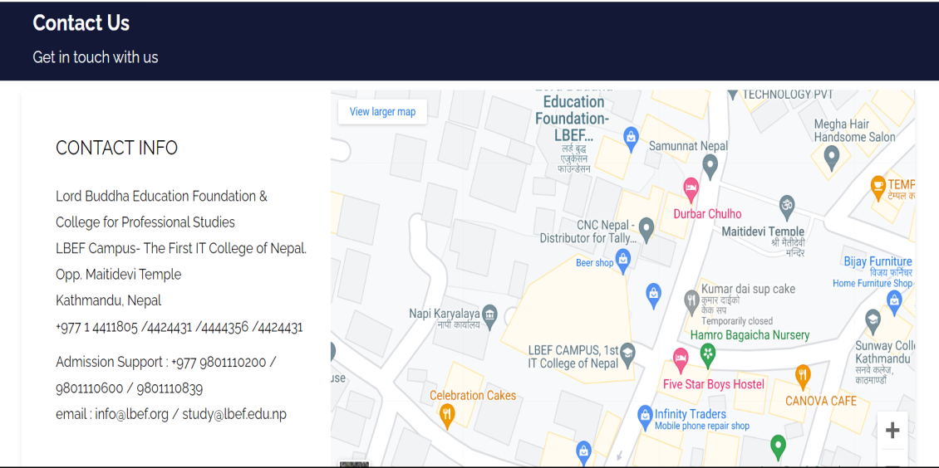

1. **Registration:** Enables users to register for events and training sessions.

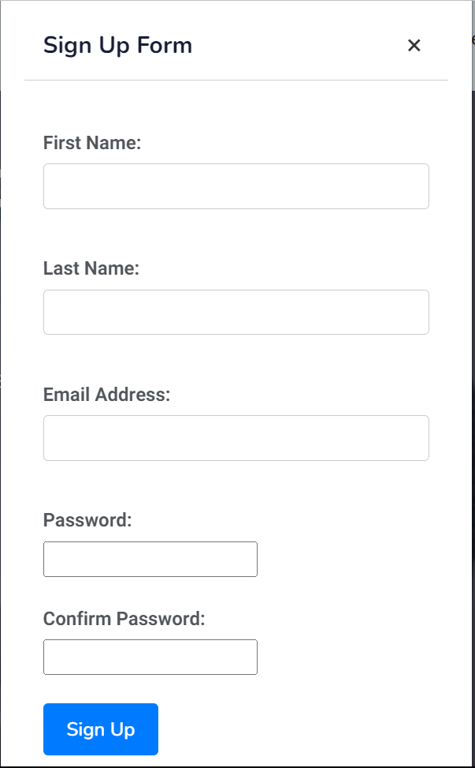

# Problem Solving

The Training and Placement Cell Website addresses the challenge of students' limited access to information about internships and training opportunities. By centralizing this information and providing a user-friendly interface, the website empowers students to make informed decisions about their career paths.

# Technical Challenges

Technical challenges encountered during development included ensuring cross-browser compatibility and responsiveness across various devices. To overcome these challenges, we employed responsive design principles, conducted thorough testing, and implemented design adjustments as needed.

Challenge 1: Cross-Browser Compatibility One of the major challenges we encountered was ensuring consistent performance and appearance across different web browsers. As modern websites need to be accessible by users using various browsers, this challenge was crucial to address.

Solution: To tackle this challenge, we adopted a progressive enhancement approach. We focused on building a solid foundation of core functionalities that work across all browsers and devices. We used CSS frameworks like Bootstrap, which inherently offer cross-browser compatibility. Additionally, we conducted rigorous testing using browser testing tools to identify and resolve compatibility issues. This approach not only improved user experience but also ensured that the website is accessible to a wider audience.

Challenge 2: Responsive Design Across Devices In today's mobile-first era, ensuring that the website is responsive and provides a seamless experience across various devices (desktops, tablets, and mobile phones) was a critical challenge.

Solution: We implemented responsive design principles to ensure that the website's layout and content adapt dynamically to different screen sizes. This involved using media queries and flexible grid systems. For instance, when designing the internship listings page, we faced difficulties in arranging content for smaller screens without sacrificing usability. Our solution was to prioritize key information, use collapsible elements, and adjust the layout to maintain readability and navigability on smaller screens.

These challenges taught us the importance of adaptability and problem-solving in web development. Through effective teamwork, consistent testing, and research, we were able to implement solutions that enhanced the user experience and ensured the website's functionality across various scenarios.

# Future Enhancements

While the project's scope is focused on addressing the immediate needs of the Training and Placement Cell, there are several potential enhancements that could be considered in the future:

1. **Online Internship Application System:** Implement a system allowing students to apply for internships directly through the website.
2. **Chatbot Integration:** Incorporate a chatbot for real-time user assistance and answering common queries.
3. **Alumni Job Board:** Create a platform for alumni to post job opportunities exclusively for current students.
4. **Webinars and Online Courses:** Offer interactive webinars and online courses to further enhance students' skills.

# Conclusions

The Training and Placement Cell Website project successfully achieves its objectives by providing an intuitive platform for students and stakeholders to access career-related information and opportunities. The website serves as a valuable resource, fostering collaboration between students, alumni, faculty, and industry partners.

# References

# Work matrix:

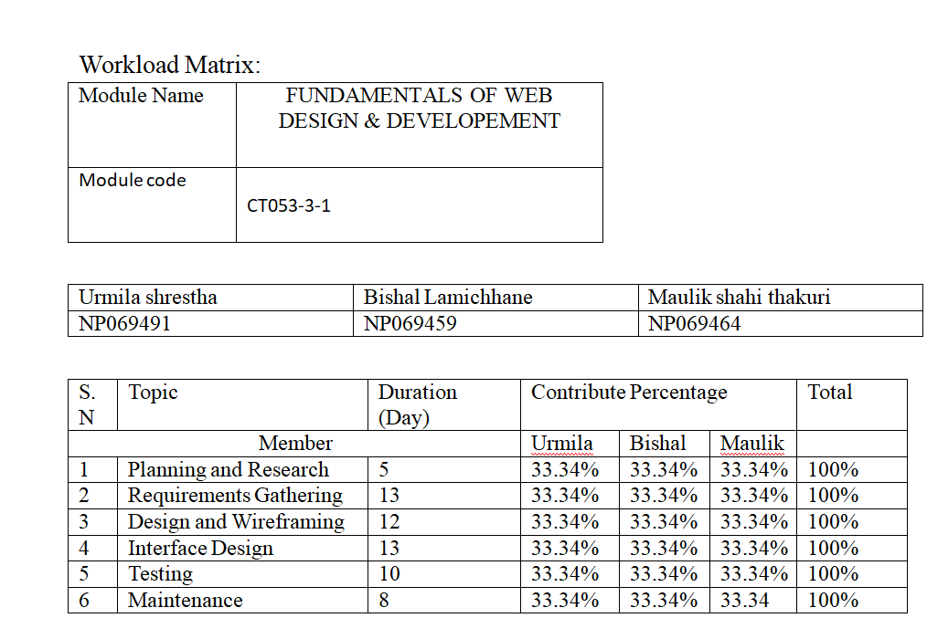

Grant chart:

